About me

* My doctoral research spanned seven years and involved over one thousand children.
* After completion I was awarded a Economic and Science Research Council Post Doctoral Fellowship.
* I have been interviewed many times for the BBC, ITV, newspapers and radio.
* Spoken at numerous mainstream national and international education conferences
* Have a long publishing record.
* I have worked as an expert witness at court since 2002.
* My work has been cited at Westminster Debates (UK government) on several occasions.
* I am a qualified and registered child & educational psychologist
* I have been attached to Durham University and the Open University
* I have taught in secondary schools and for some years was a Local Authority appointed school governor.

<http://www.youtube.com/watch?v=-Kobdb37Cwc> to 1.20

**Dr Paula Rothermel**

Rethinking Education, Embracing Choice and Diversity

**Hong Kong, 10-13 October 2014**

**This paper is extracted from a book in press:**

**Rothermel, P. J. (in press) ‘What We Know About Home Education’. UK: CreateSpace**

**Another book is due out shortly afterwards in February 2015:**

**Rothermel, P. J. (in press) (ed) Intercultural Perspectives on Home education: Do we need schools. London:Palgrave Macmillan.**

**SLIDE 1 time to talk later**

**SLIDE 2 header**

**SLIDE 3 who am I**

**SLIDE 4 publications**

**SLIDE 5 books to come out**

**SLIDE 6**

**What we know about home education and the lessons we can learn**

[](http://www.google.co.uk/imgres?imgurl=http://mrsolszowy.pbworks.com/f/1238979090/education_cartoon.jpg&imgrefurl=http://mrsolszowy.pbworks.com/The-Lighter-Side-of-Teaching:--Educational-HUMOUR&h=350&w=271&tbnid=F8C5dBaxc4HKhM:&zoom=1&docid=C7JSvXBeLZkFyM&ei=JCozVN_qHYfiywOcmoLIBw&tbm=isch&ved=0CA4QMygGMAY4ZA&iact=rc&uact=3&dur=3278&page=8&start=97&ndsp=14)VERSUS **[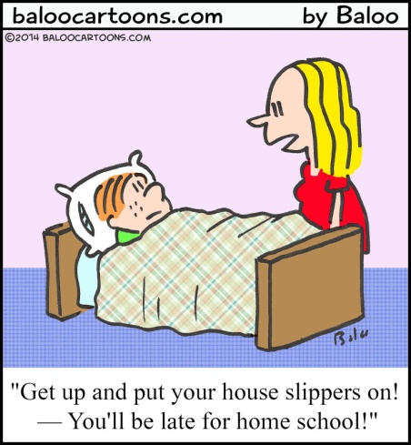](http://3.bp.blogspot.com/-VE2J3NIIRtA/UuAI1PBE5QI/AAAAAAAAg80/KC0g3sl2xak/s1600/1lateforhomeschoolCOLCP.jpg)**

**SLIDE 7**

I am going to talk about:

* CV & Publications
* Summary of my research
* Statistics show that children make a huge leap forwards when they enter school
* What we know about home education
* Criticisms
* Children are active in their own learning
* Later school starting age
* Influence of love (the undervalued power of love)
* Conclusions

**Slide 8**

**Parental Choice**

Decisions concerning how and where children are educated and of what that education should consist lie ultimately with parents, as detailed in Protocol 1, Article 2 of the European Convention on Human Rights (1952), adopted through the Human Rights Act 1998 into UK law, 2nd October 2000.

'No person shall be denied the right to education. In the exercise of any functions which it assumes in relation to education and to teaching, the State shall respect the right of parents to ensure such education and teaching in conformity with their own religious and philosophical convictions.'

Protocol 1, Article 2 of the European Convention on Human Rights (1952)

**Slide 9**

1. **Summary of my Research**
   1. 'Notschooled' children make an extremely interesting group to study. Study of them is one way we can know more not just about home education, but also the value of school for children.
   2. Many studies aim to evaluate children's learning and attitudes to school, and yet none of these studies has ever used as a control, children whose families are electively home-educating.
   3. My own research offers a window into home education. I studied the academic results of home educated primary aged children in the UK. My study looked like this:

**Survey Data:** 419 home-educating families and 1,099 children

**Slide 10**

**Educational Data:**

* PIPS Baseline Assessment

N=35 children 4-years-old

Assessed at the beginning of a 9 month period and again at the end

* PIPS Year 2 Assessment

N=18 children 6 to 7-years-old

* National Literacy Project Assessments (total n=49)

NLP Year 1 (N=17) children 5 to 6-years-old

NLP Year 3 (N=15) children 7 to 8-years-old

NLP Year 5 (N=17) children 9 to 10-years-old

**Psychological Data:**

* Goodman Strengths and Difficulties Scale (SDQ)

N=44 children aged 4 to 11-years-old (adult informant)

N=7 children aged 11-years-old (self rated)

* Revised Rutter Scale for School Aged Children

N=42 children aged 5 to 11-years-old (adult informant)

* Children's Assertive Behaviour Scale (CABS)

N=43 children aged 8 to 10-years-old (self rated)

**Interview Data:**

N=100 home-educating families.

**Slide 11**

* 1. And I found.....
  2. My research[1] included baseline assessment of 4-5 yr olds tested twice over a ‘school’ year. I found that 64% of the children tested scored over 75% on the assessment, whereas nationally just 5.1% of children scored over 75%.
  3. In the maths and literacy assessments of home educated children, Rothermel[2] used national tests and results data to enable comparisons. She found that where 16% of schoolchildren nationally scored within the top attainment band, the same level was achieved by between 52% and 96% of the home educated children (over four age bands - 6,7,8 and 10 year olds).

**Slide 12**

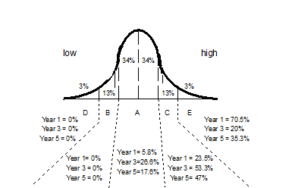

**Slide 13**

* 1. Some of the children achieving these scores were learning in unstructured ways and with little, if any, work undertaken whilst sat down at a table. In my 2002 work I discusses children's ability to digest and incubate[3] their ideas, allowing them to develop their ability to think and analyse for themselves. This process may be slower than taking in information through formal methods but is, perhaps, more durable[4].
  2. The real question from is not so much about why home educated children outperform school children, but rather, why some school children do so poorly. I propose the idea that the traditional school model may depress learning for some children, whilst the freedom of home education may enhance children's learning experience. Critics would argue that home educated children, i.e. children with committed parents, would all have done even better at school.

**Slide 13**

1. **Statistics show that children make a huge leap forwards when they enter school**  (note: research does not always mean what we are told it means)

**Slide 14**

* 1. Tymms, Merrell and Henderson (1997), (using PIPS) concluded that the initial year at school is the one where pupils make the greatest advance in learning. They suggested that in comparing attainment between children who had not yet been to school and those of the same age who had attended for one year, the variance in scores signified that school made a 'massive difference' (in reading and maths').

They reported that:

'[…] it is hardly an unexpected finding to discover that teaching advances learning […]. […] For progress what really mattered was attendance at school, the pupil's prior achievements and the school that they attend.'

Tymms et al. (1997 p. 117)

* 1. Tymms et al. (1997) found that the difference in performance between the youngest and oldest children (11 months difference) in their cohort was far less than the difference between children's 'Start' and 'End of Reception' scores. Tymms et al. suggested that the 42 point increase they found, as highlighted below in Table 2, was associated with schooling. Rothermel 2002, albeit with a very small cohort, also using an 11 month age range (48-59 months, n=22), encountered almost the same phenomenon, but with a difference of 45.32 points.

Table 2:data extracted from tymms et al. 1997, contrasted with this study's data

|  |  |  |  |  |
| --- | --- | --- | --- | --- |
|  | **Tymms et al. (1997)** | **Rothermel (2002)** | **Tymms et al. (1997)** | **Rothermel (2002)** |
| **n** | **283\*\*** | **12\*** | **1700** | **22** |
|  | 'Start of Reception' point difference between the oldest and youngest children's scores | 'Start of Reception' point difference between the oldest and youngest children's scores | Progress in points for whole group between their 'Start' and 'End' of Reception scores | Progress in points for whole group between their 'Start' and 'End' of Reception scores |
| **Points** | 18 | 10.22 | 60 | 55.54 |
| **Increase in scores between 'Start' and 'End of Reception' and 'End of Reception'** | | | (60-18=)  42 | (55.54-10.22=) 45.32 |

*The two groups of children at each extreme of the 'Start of Reception' year group consisted of, oldest (n=8) and youngest (n=4), thus totaling 12.

**Oldest (n=117) and youngest (n=166), thus totaling 283.

**Slide 15**

[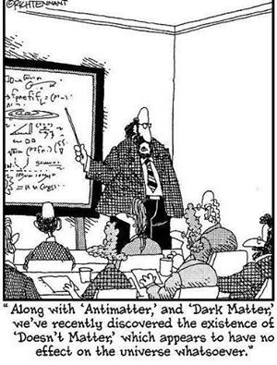](https://www.facebook.com/353739560014/photos/a.10151237768610015.797948.353739560014/10153882913055015/?type=1)

Quite possible and likely, however, is that children between 4 and 6 simply do make a seismic shift in their cognitive development and that it doesn’t matter if they are at school or not.

My findings, using the same test material, was that the difference in test scores between the youngest and oldest at ‘entry’ was 12 points and that the difference between the average grade on ‘entry’ and ‘exit’ was 54, meaning my cohort increased their grades during that year by 45.32 points as opposed to Tymms 42 point average.

**Slide 16**

* 1. Why? Tymms et al. (1997) used the 42 point advance as evidence of the effectiveness of school. However, there may be other reasons why the progress score is greater than the score difference between the 'Start of Reception' oldest and youngest children.
  2. It is conceivable, that the 'enormous progress' found by Tymms et al. (1997) is, in fact, the result of the children's disorientation and acclimatisation to their new situation. .
  3. In contrast, parents of the home-educated children tended to have planned for home-education from very early on; thus the parents had generally given more attention to their children's early learning. This theory would indicate a ‘higher starting place’ (there was) and slower progress (as in maths).
  4. Quite possible and likely, however, is that children between 4 and 6 simply do make a seismic shift in their cognitive development and that it does not make much difference if they are at school or not.

**Slide 17 & 18**

* 1. Rothermel (2004) found that the head start seen in the home educating cohort was maintained at least until the age of 11 years. The Charts below show that the group began the year ahead of their school counterparts and ended it still ahead.

Chart 3: home-educated children's individual reading performance

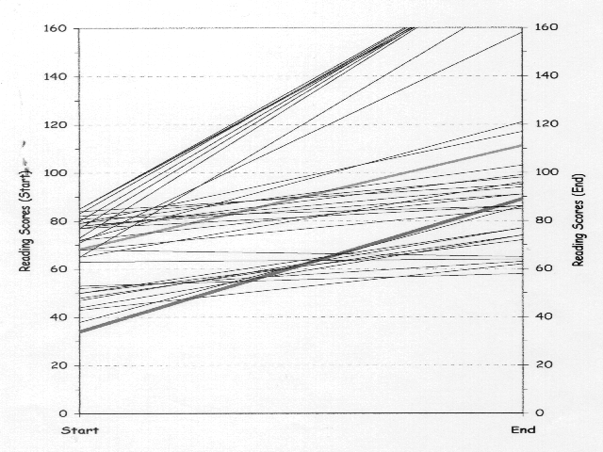

**National mean**

**Home-educated mean**

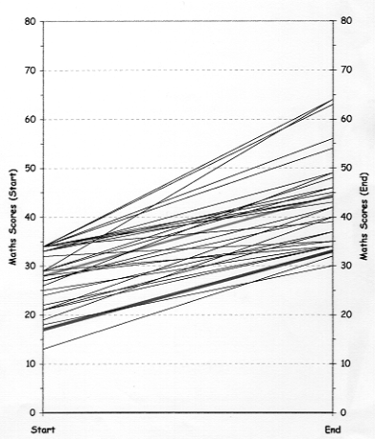

**Home-educated mean**

**National mean**

Chart 4: home-educated children's individual mathematics performance

* 1. If school does not make a difference over and above this developmental jump, then the choice for the parent, is about the quality of the experience they would like for their child during these years.

**Slide 19**

**Emergent issues from my research**

* Poverty was not an indicator of poor academic outcomes where parents, whatever their situation, were committed to their children.
* The children may have performed so well because they were not under pressure when taking these tests.
* Home-education was far more successful and efficient than even the parents anticipated.
* There was evidence of metacognitive thought - the children were aware of their limitations.
* Learning in families was negotiated and differentiated for each child.

**SLIDE 20**

* If agencies adopt psychosocial 'norms' by which to judge such children, they will almost invariably find these children to be outside the 'norm'. What is desirable behaviour from a schoolchild is very different from what is deemed desirable behaviour from a home-educated child.

**SLIDE 21**

* baseline assessments were not useful in finding out about the home-educated children .
* The tests gave no insight into the extent of these children's learning. The research found that the children's learning was best described as a multidirectional and mutlilayered model, and that such a model was not provided for by standard tests.

**SLIDE 22**

**WHAT WE KNOW ABOUT HOME EDUCATION**

**SLIDE 23**

* 1. ***The range of ways in which children are educated at home.*** Home education can take a variety of forms ranging from the formal to the informal. However, it should be understood that formal home education is not in any way the same as formal school education. The overall format for home education is characterised by liquidity and flexibility, and can be described as follows:
     1. All the types of home education can be set along a spectrum from an informal child-led approach, through a mid point, to a didactic, parent-led style. All approaches on this spectrum are child-centred in that the education revolves around the individual child or children's needs.
     2. Families often use different approaches for different children, thus whilst one child may prefer a workbook or curriculum led education, another child may respond better to a more liberal style.
     3. Parents tend to adapt their approach depending on age. Researchers such as Thomas (1998) have found that families who have recently withdrawn children from school tend to follow a curriculum initially but that they relax this over time as they move to a child led approach. However, Rothermel (2002) has concluded that where there is a change in style, parents of children home educated from birth tend to move from the informal to the formal, that is, the reverse of parents who have withdrawn their children from school.
     4. a simple definition of the styles is as follows:

1. ***Child-led.*** These families tend to take each day as it comes and to follow the children's lead.
2. ***Mixed.*** These families will adopt more of a shared approach to learning. The parents may expect some formal input from the children but will also follow the children's lead in giving them plenty of freedom to decide for themselves what they want to do***.*** 
   1. ***Parent-led.*** It is more likely that these children will follow a purchased curriculum and their parents will take all decisions about how the children's days are organised.
   2. ***Change over time.*** Rothermel (2002) found one of the most noticeable characteristics of home education was that of ‘change over time’. Not only did parents adapt and alter their approach to how they educated their children over time but the parents’ motives at the outset were soon superseded by other, different motives as they became more immersed in the culture of home education.
   3. ***Types of home educators.*** The stereotypes of home educators are that either they are hippy rebels or hothousing fanatics[5]. Typically, they are referred to as if they were a ‘type’ of parent. In fact, nothing could be further from the truth as Rothermel (2005) discusses at length. Home educators tend to have little if anything in common with each other beyond their decision to home educate and a desire to take full responsibility for their children. (this can also be described as a wish to take control). The willingness to join forces to take advantage of educational rates on activities is a feature peculiar to home education. Home education is not a homogenous activity but is undertaken in very differently ways by very different people, even within groups (i.e religious groups).
   4. ***Time spent on home educating.*** Rothermel (2002) found that 62% of families tended to enjoy a mix of academic and informal education on a daily basis, with some families keeping to this more strictly than others. Rothermel found that children were assisted in their learning by their parents facilitating resources, interests and visits, by following and sharing interests, and through discussion by listening and making time to answer their children's questions. This style of education involves the full time attention of at least one parent, although that time may be shared between two parents, perhaps working part time.
   5. Professor Desforges[6] reports that "Our findings show that it is the (parental) involvement of learning activities in the home that is most closely associated with better cognitive attainment in the early years". Given that the recent ONS data[7] on the amount of time that parents spent in child care each day is an average of just 32 minutes a day, it can be anticipated that home educated children, whose parents typically are involved in their learning activities for many hours each day, can be expected to demonstrate good cognitive attainment.
   6. Home education with its individually paced, child-centred approach to learning appears to provide the necessary time for children to absorb, assimilate and understand challenging problems. In school, such cognitive challenges have been found to take up just 1 per cent of lesson time[8] in contrast with home education where cognitive challenges typically are a characteristic feature. Professor Karmilloff Smith[9] has generated ideas about 'incubation' periods whereby children take time to absorb and unravel problems presented to them.
   7. ***The pressures on parents who choose to educate their children at home.***My research shows that the most common pressures cited by families who home educate are: other people's opinions, not being accepted in their community and the ensuing isolation that this brings; parents not having enough time for themselves; financial worries; the exhausting and time consuming nature of home education; and the potential is a lack of resources. Some parents also say they feel pressured by the responsibility of home educating. Beyond this, I have identified other pressures as follows: pressure to perform; having children who are late readers; family and friend pressures; and children informally labelled as hyperactive by others. Despite the pressures linked to home education, research suggests that home educated children grow into capable adults and that many of them chose to home educate their own children[10].
   8. ***Other people's opinions and ensuing sense of isolation.*** The sense of isolation and lack of acceptance in the local community can cause children to suffer, making them feel awkward and shy. It is not uncommon to hear home educated children complain about they way the feel they are being interrogated by strangers on the street during school hours. Some of this may be well-meaning interest, but too often it causes distress to children and increases their sense of being different. Sometimes members of the public assume the children have special needs and questions about reading and writing are common.
   9. ***Lack of money.*** Many parents find it difficult to cope without time for themselves and where money is tight, this can certainly place a strain on relationships within the family, who after all, are in much closer contact that would be the case in a family with school children.
   10. ***Lack of time for parents alone.*** As regards the lack of time for themselves, parents often overcome this by negotiating their time with their child to allow for some time alone. However, this does remain an issue. In my experience parents who continue to home educate come to accept this as an inevitable aspect of home education.
   11. ***Financial worries.*** When home educating financial pressures tend to either remain, or be absorbed, into the 'culture' of the family. Generally speaking, home educating families live on one income and tend to be less well off than their school educating peers. Research shows, however, that parental income is not a predictor of poor attainment[11].
   12. ***The exhausting and time consuming nature of home education***. Research from Australia[12] has identified maternal overload as a problem because of the commitment and responsibility of home education which so often falls mainly to the mothers. However, in my research both mothers and fathers expressed concerns over this issue. This pressure can be reduced when families get together and share some of the associated responsibilities. Some local groups meet up weekly and parents can relax in a group care situation.
   13. ***Lack of resources.*** Concerns over resources are overcome as families share resources, ideas, discount cards etc. The increasing use of email discussion groups by home educators had led to a further sharing of resources.
   14. ***Pressure to perform.*** Home educators known to their LAs often feel under pressure to demonstrate that their children are achieving to the standard that they would if they were at school. LAs do sometimes put particular pressure on parents who feel less sure in their decision and this ultimately leads to some parents ceasing to home educate.
   15. ***Having children who are late readers.*** Home educated children may appear to make slower progress with their reading and writing than school children. This tends to be because their parents prefer to let them learn at their own pace. This attitude is sometimes, but should not be, confused with schools' poor readers, whereby the children may be experiencing real problems with their reading. Many home educators adopt this slower pace approach to reading and writing[13] and there is no research that I am aware of indicating that this method leads to later problems. Research shows that late readers soon catch up with their earlier reading peers, often becoming keen readers[14]. Nevertheless, for some parents, having a child aged 6-10 years who cannot read, can and does lead to criticism of their decision to home educate and to labels of dyslexia. The research[15] shows that these late readers tend to become competent and avid readers.
   16. ***Family and friend pressures.*** Rothermel (2002) showed that friends and families, particularly in the early days, can put home educating parents under considerable pressure. As new home educators build friendships within the home educating community the force of this pressure diminishes, but initially it can cause a great deal of distress and some families decide not to continue with their home education.
   17. Through my research, I have interviewed families where there is disagreement over home education between spouses. Generally, this is where the mother wants to home educate and the father does not.

**SLIDE 23 & 24**

* 1. ***Children labelled by others as hyperactive***. At 4 or 5 when school children are usually able to write and read a little and sit for periods at their tables engaged in teacher directed activities involving concentration, the home educated child of this age is very often still at a play based stage, where he or she is not required to sit and learn or raise a hand to ask a question. It can seem, to an onlooker, that these children are hyperactive, unable to engage in 'proper' activity, and that they are unruly.

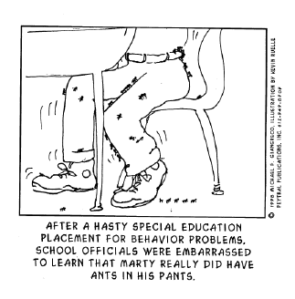

**SLIDE 25**

* 1. ***Moving from home to school education***. Whilst my research indicates that home educated children who decide to give school at try usually manage the transition very well, it is the case that a change from home education to school education brings not only a change in educational format but encompasses a change of lifestyle and friendships for both home educated children and their parents.
  2. ***How long does home education last?*** Families who home educate from birth to 16-18 years of age are in the minority and tend to be those with larger families. Within home educating families, children who, over the compulsory education years, experience a school and home education mix, are likely to be in the majority (this would need retrospective research to fully establish this).
  3. Rothermel (2002) found that from the 419 home educating families whose questionnaire responses were analysed, 20% of families had at least one child in school and 47% of families had home educated children who had previously been in school.
  4. Also in that research, a third of the home educating parents said there were no plans for their home-educated children to attend school in the future, as opposed to 14% who said they would. A further half were open minded, many indicating that it would be the children's decision.
  5. Where parents said that their children might later be in school, respondents said this was either, because it would be what the children wanted, or for easier access to exams, university and extra resources; other parents explained that it might be 'best at the time' or because home education became ‘too much of a struggle’, parents might both need to work full-time or because it was 'God's will'.
  6. Home education can be suitable for some children, some of the time, and families are likely to follow their children's needs rather than steadfastly insist on home educating regardless.
  7. Research[16] looking specifically at children's transition from home to school and from school to home education has found that children moving from home education into school tend to adjust well where teachers are "helpful, professional and considerate[17]". Children whose parents decide to send them to school usually believe that it is in the child's best interests, although these interests vary from child to child[18].
  8. ***Formal Qualifications.*** Children who are home educated are able to take the same formal educational qualifications as school children. However, in practice this often requires strenuous efforts on the part of the parents in negotiating the minefield of taking exams outside school.
  9. ***Do home-educated children get jobs?*** We do not know in the UK how home educated children perform in the labour market.

**SLIDE 26**

* 1. ***Criticisms***. Critics of home education criticise home education for the lack of exposure to diversity, the lack of participation in greater society and the potential difficulty entering mainstream life[19], but there is no research evidence that I am aware of to support this viewpoint. Research with home-educated adults indicates that they contribute far more to community activities than their schooled counterparts[20].
  2. Criticisms of home education research often centre on the fact that much of the US research uses Christian samples and that in many cases, particularly in the UK, families are not randomly selected for participation because home educators are not required to register their home education nor undergo any summative assessment on a national scale and their data cannot therefore be plucked from a database. In contrast, school educated children are both registered and tested and their attainment data is stored electronically and accessible without express permission from the children concerned.
  3. In the UK Home educating families often report that they feel vulnerable to criticism by non home educators on the issue of their children's socialisation and assumed isolation (Rothermel 2002). This exposure to criticism may well stem from the lack of information held by LAs and government about home educators.
  4. In 2009 the UK Badman Review was set up to investigate claims that home education could be used as a cover for sinister activities. However, the following year, the Children, Schools and Families Select Committee (CSFC 2010) rejected his statistics finding:

“Given the lack of information on the actual numbers of home educated children we suggest it is unsafe for the Badman review to have reached such a strong conclusion about the relative risks of a child being home educated or school educated”

(CSFC 2010)

**SLIDE 27**

[](http://www.google.com.hk/url?sa=i&rct=j&q=&esrc=s&frm=1&source=images&cd=&cad=rja&uact=8&docid=9WHnHW83z2mzIM&tbnid=AtUTAWsqCg5x8M:&ved=0CAcQjRw&url=http%3A%2F%2F3dlearners.blogspot.com%2F2012_04_01_archive.html&ei=J9c3VKT7DNXo8AXvnoFw&psig=AFQjCNFWpQclZ6p15dYUroh9AZStx__gkw&ust=1413032060912182)

**SLIDE 28**

1. **CHILDREN ARE ACTIVE IN THEIR OWN LEARNING**
   1. Piaget taught us about the tremendous capacity for children to self organise and learn from the inside out.
   2. Karmiloff-Smith described the way in which children take on board information from the external world, reorganising it internally and combining it through conflict and, or agreement with previously internalised knowledge, eventually attaining mastery over the situation. She described this process as 'representational redescription' (RR).
   3. In terms of informal learning, Rothermel (2002) and Thomas and Patterson (2008) conclude that in the home education context, children absorb their knowledge gradually by virtue of informal repetition, and assimilation through everyday learning involving the natural process of dialogue and exploration. This style of acquiring information has been found by researchers to be beneficial (e.g. Edmondson 2006).

**SLIDE 29**

1. **LATER SCHOOL STARTING AGE**

1. Research supporting a later starting age for formal education in the UK is growing. In many states of the US, formal education does not begin until children are aged 6, 7 and in Washington and Pennsylvania 8 years of age[21]. In Finland[22], formal education does not start until the year that children turn 7, and in Sweden it is also usually 7 but can be postponed until 8 years of age[23].
2. A number of organisations have sprung up in the UK, lobbying for a later school starting age, such as, the “[Too Much, Too Soon](http://www.toomuchtoosoon.org/) campaign”.
3. The concept of ‘school readiness’ is a new one and is often confused with simple ‘readiness’, not forcing children to learn a task or a skill until they seem competent. By talking parents into believing in ‘school readiness’, the state plays to the ego of the parent. A parent whose child goes a earlier to school is often proud to say, “He’s ready for school”. This implies the arrival of a time when a child is ready to learn what the state decide it should. This ebbs away at the intuition and inventiveness of parent power.

**SLIDE 30**

1. For example the 2009 Cambridge Review of Primary Education argues for delaying the onset of formal schooling until aged 6, on the basis that 5 year olds risk having confidence dented by early formal education.
2. The line taken is that 90% of the world start formal schooling aged 6 or 7 ([World Bank data](http://data.worldbank.org/indicator/SE.PRM.AGES)) and that research shows that children starting school aged 6 or 7 perform better on educational testing as well as higher levels of well-being. This seems born out by UNICEF 2009 report on children’s happiness which places the UK at the very bottom in world rankings
3. My research indicates that the early ears are perhaps the ideal time to leave children alone and let their brains mature without ‘forced’ government agenda determined curriculum. That if we are looking to create innovation in our next generations, the last thing we should be doing is prejudicing their brains at the very time they should be left open to wonder at the world and start to make sense of it for themselves

**SLIDE 31**

1. **INFLUENCE OF LOVE (The Undervalued Power of Love)**
2. During recent years there has been a wealth of information concerning the importance of parental involvement in children's development. This was highlighted in a government funded meta analysis of 14 studies which concluded:

"Parental involvement in the form of ‘at-home good parenting’ has a significant positive effect on children’s achievement and adjustment even after all other factors shaping attainment have been taken out of the equation"

(Desforges and Abouchaar, 2003 p. 4)

1. The UK DCSF funded Family and Parenting Institute further supports this finding, stating, “It is now well evidenced that the home learning environment is more influential in determining children's outcomes than parental occupation, education or income” (FPI 2009).
2. Further, the 2009 Children’s Society report concluded: “A child’s relationship with their parents is pivotal in them achieving a good childhood” and Sylva et al. (2003), described a parenting style that has been as making the greatest contribution to children's attainment, that of the, ‘involved parent’.

**SLIDE 32**

1. Input into a child’s learning can involve as little as just being there for their child, answering or helping to answer questions as and when they arise and facilitating resources and activities (Rothermel 2002).
2. Professor Layard has written about the economic value of happiness (Layard 2003). Further, Research has shown that brain development is inseparably linked to love (Gerhardht 1994).
3. Tizard and Hughes (1984) found that parents had the advantage of understanding the context of their children's lives in a way that teachers couldn't. In the last lines of their book they write:

'Indeed, in our opinion, it is time to shift the emphasis away from what parents should learn from professionals, and towards what professionals can learn from studying parents and children at home.'

Tizard and Hughes (1984, p 267)

1. Why, when it is well established that parental involvement is the most important factor in a child’s achievement, are they not trusted to be involved in their children’s learning after the aged of between 3 and 6 (depending on the country). Surely if parental input is so strong, the state would be offering to pay parents to stay home and take over the early years education?

**SLIDE 33**

1. **CONCLUSION**

Once we stop believing in our own capacity as parents to encourage our children, once we are so dependent on being told what to think, there will be no one left to ask questions or to question the wisdom of the state. Once faith goes, there is nothing left.

1. Rothermel, P. (2004) Home-Education: comparison of home and school educated children on PIPS Baseline Assessments, Journal of Early Childhood Research Issue 5.
2. Rothermel, P. J. (2005) Home-based education: Academic Assessments with children aged between 4 and 10 years. *Submitted to the Journal of Educational Psychology.*
3. Karmiloff-Smith, A. (1994). Precis of Beyond modularity: A developmental perspective on cognitive science. *Behavioral and Brain Sciences* 17 (4): 693-745.
4. Pine, K., Messer, D. and Godfrey, K (1999) The teachability of children with naive theories: An exploration of the effects of two traditional teaching methods. *British Journal of Educational Research.* 69 201-212.
5. Hothousing is a term used describing an intensive education leading to early achievement.
6. Desforges and Abourchaar (2001)
7. www.statistics.gov.uk/CCI/nugget.asp?ID=7&Pos=&ColRank=1&Rank=374
8. In her analysis of over 1,000 lessons, Professor Diane Montgomery of Middlesex University found that 70 per cent of periods where pupils and teachers were interacting was taken up by the teacher talking, while only 1 per cent involved cognitive challenges where pupils worked things out for themselves rather than being fed facts. She believes that this is partly the fault of an overloaded curriculum which leaves little time for creative thought (Dodd 1998).
9. Karmiloff Smith (1992)
10. Ray (2003) , Knowles and Muchmore (1995). Knowles (1991)
11. Desforges and Abourchaar (2001) and Rothermel (2004a,b)
12. Trevaskis (2006) The Danger of Maternal Overload and Maternal Distress. Available on line at http://www.home-ed.vic.edu.au/category/parents-stories/. Trevaskis has undertaken research with home educated children with learning difficulties.
13. As Thomas (1998) has found,
14. Thomas (1998)
15. Thomas (1998)
16. Jackson (2006)
17. ibid
18. Jackson (2006) - citing her own work and that of Snyder (2005) and Stoppler, (1998)
19. Murray (1996)
20. Ray (2003) surveyed over 7,300 home educated adults 5,000 of whom had been home educated for at least seven years. He found that whilst only 37% of US adults participated in community activities, 71% of the home educated adults were involved in such activities.
21. HSLDA (2004)
22. Ojanen (2004)
23. Estia (2004)